May 5, 2020
Operation Committee Meeting
1200 west 35th St, River Level
Meeting started at 12:00pm via Zoom
Attendance: Bill Derrah, Jerry Thomas, Glenn Braun, Don Glasell, Dylan Hoffmann, Jim Jarecki, Kath Thomas, Ked Fairbank, Lorraine Freeman, Mary Ann O’Rourke, Patrick McBriarty, Stan Mehaffey, Trigg Waller.
Next meeting: Tuesday, June 2 at 12:00pm.
Agenda:
Approval of April Minutes
- Operations Chair Report
  - Proposals from Collections
  - Collection and Archive Report
    - CMM Collections Policy, stage 1 (attached)
    - Mural proposal (attached)
  - Membership Report
  - Model Shop Report
- Thoughts on how to proceed based on COVID-19
  - Gala Prospects—Tentative new date 10/22/2020
  - Museum—Re-open date?
- 3rd Fridays
  - Still On hold during lockdown
- Communication Committee Report—Mary Ann
  - Web Site
  - Newsletter
  - Outreach to Social Media and to/with other museums. Anyone connected with Ken Griffin to get on the Mayor's list of visits to cultural institutions during COVID -19?
- Exhibit Proposals: Updates
  - Anchor Exhibit (external display)—Trigg Waller
  - Possible project of obtaining and moving a tug from Crowley’s and displaying it at Bridgeport—Trigg Waller
- Old Business
  - Membership ideas
  - Other ongoing items
- New Business

Approval of April Meeting Minutes:
Trigg moved to approve the April minutes as distributed. The motion was duly seconded and passed. April minutes are ready for posting.
Operations Chair Report:
Donor campaign created. A list of donors and a script has been put together for those who would like to help with the Donor campaign.

The Board has met and concluded that financial demands will be met for May.

We will continue to raise funds in many ways via grant requests and membership appeals. The status of the grants (completed and in the works) will be relayed to the operations committee when news is available.

The Board has heard the operations committee’s request about redesigning the south side hall of museum and the proposed new Bill Pikney exhibit. The Board is excited with the idea and also acknowledges the incomplete Novak and Frese exhibits. The next phase for the operations board will be to start funding at least one exhibit at a time and create a reconstruction plan for the south side hall.

Proposals from Collections-
Collection and Archive Report-
- CMM Collections policy, stage 1- Dylan created a draft collections policy that all should have reviewed before this meeting. Dylan has also sent the draft to our MAP assessor, Lindy Dosher, for review. We are currently waiting for Lindy’s feedback on the policy to make any more necessary changes.
- Mural proposal- Dylan has finished the mural proposal and all should have reviewed it before this meeting. When agreed upon, Dave Metzger will sign off on the proposal so we may obtain the mural and begin creating the new exhibit.
Important notes about mural proposal: The mural will NOT be displayed IN the museum, rather in the outside hall. Worst case scenario, we would put the mural in the south storage area if needed. The mural will be CMM property so we have the rights to sell it if desired.
Patrick motions to approve Dylan’s proposal and move to the next stage, Board review. The motion is duly seconded and passed. Lorraine motions to have the mural displayed in the hallway outside the museum doors. The motion is duly second and passed. The proposal will be given to the Board for further review.

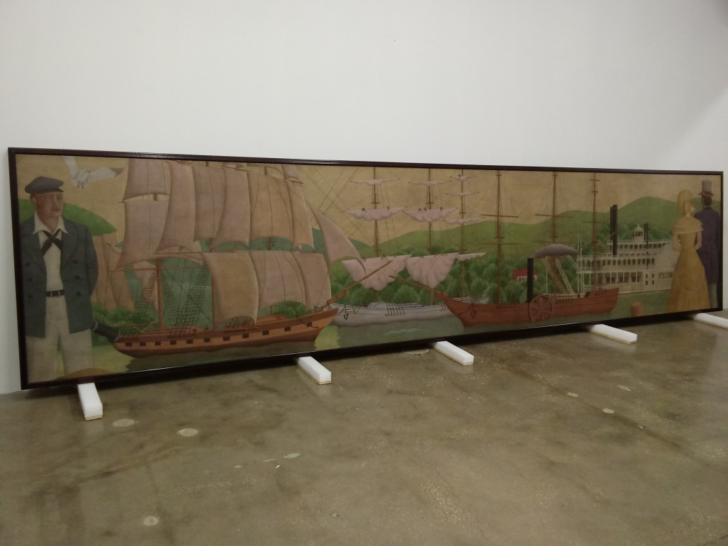

(the Acquisition Proposal is attached to the minutes. Please see PDF attachment.)

Bill would like to point out that the mural, as an object, has a separate but very interesting history than the subject of the painting: Why was this subject chosen by the painters and why was it chosen to be placed in the Rookery Building. This is an important publicity note that should be included in an article write up once the new exhibit is displayed.

Membership Report- Our membership total is now up to 194 members, 12 renewed and 5 new (16 membership totals for the month of April.) We sent out a couple donation campaigns as well as another new/ renewal membership request with the focus of increasing our amount of Supporting ($100) members. We are pleased to report that half of the memberships were made at the Supporting level.

Model shop Report- designing online classes.
Thoughts on how to proceed based on COVID-19:
Gala Prospects, new date- The committee is hoping to reschedule the gala for this fall. The CYC has given us two date options, both on a Thursday, in October, but we have not come to an agreement. The design for the mailing save the dates, invitations, and donor packets will be kept but will need to have the dates changed. Response cards and return envelopes will also be required. Jerry approached the Board and the Board approved the continuation of planning the gala. Good news is that now we have more time to recruit sponsors. A Gala Committee meeting will be held this week via zoom.
Museum re-open date- At this time, the earliest re-open date would be June 1st. If we are to reopen we must discuss and execute with proper CDC guidelines. How many people in at one time? How do we implement social distancing by 6 feet? How much PPE supplies do we need to buy?

Third Friday’s (Jim):
On hold during lockdown- Do not have a current speaker set up to present online for May. More discussion was done on the option of having speakers present on FB live (which we should start implementing sooner rather than later.) Jim will look further into this option and report back to the CMM if and how we should begin FB live videos for our Third Friday speakers during the shelter- in- place.
Communications Committee Report (Mary Ann):
Web Site- The Support Us page on website needs redoing and update or remove the “support us” tab at bottom of home screen. The donation tab via “Donor Box” must be removed so that the donations go directly into our FlipCause account (Ked set up Donor Box). Dylan made a new page called “Online Stories” which currently features a slide show about the history of the Grebe ship yard. We will be promoting the Online Stories in the newsletter. Discussion was brought up about the need to watermark our photos and post in low resolution as to protect our property. There is possibly a copy write issue with the song “Beyond the Sea” that goes with the slide show. We may need to take the song out just in case.

Newsletter- The newsletter is with Lorraine in design. Lorraine will design the newsletter in Constant Contact. Ronnie will review the format and text and send preview to Mary Ann and Lorraine before officially sending. The lead story is on Ked’s retirement. We also will have a few “learn and teach from home” articles in this month’s issue on the I&M Canal.

Outreach on Social Media to/ with other museums- Ken Griffin is helping promote museum visits with Mayor, Lori Lightfoot. We want the mayor comes to us! Anil Ahuja is said to have strong ties with the mayor. Maybe go through Anil to get this to happen. Jerry and Mary Ann will follow up with Anil.
Exhibit Proposals (Updates):
Anchor Exhibit, external display (Trigg Waller)- Trigg has assessed the newly proposed location at the BAC and reports that it is not ideal. He is going to discuss options about having the location of the Anchor displayed in its originally proposed area.

Jim asks if he can make an additional proposal for the anchor display that involves conservation of the anchor. Jim will draft a proposal and consult with Trigg about his ideas.

Possible project of obtaining and moving a tug from Crowley’s and displaying it at Bridgeport (Trigg Waller)- Trigg has nothing new to report. He is still waiting on Grant Crowley to respond back. It is important to note that the Tug boat will NOT be owned by the CMM. It is owned by Crowley’s.

Old Business:
Membership ideas- Ked proposed the we include a Mr. Canoe or the Eastland movie as a membership incentive. Lorraine agrees. Another idea, more related to today’s time with COVID, we could design our own CMM masks to sell in the store (we have CMM iron patches in storage we could utilize).

Other ongoing items- nothing to report.

New Business:

Nothing to report.

Meeting adjourned at 1:11pm
Submitted by:
Veronica Caminiti

Status of New Exhibit Proposals

- Anchor exhibit- new, discussed by committee, committee approval awaiting final proposal to be created by Trigg

- Bill Pinkney exhibit- new, discussed by committee and approved, proposal drafted (in stage 2) by Don and submitted to the Board

- Tugboat exhibit-new, discussed by committee, committee approval awaiting final proposal to be created by Trigg

- Schooner mural exhibit-new, discussed by committee, committee approval awaiting proposal to be created by Dylan

- World War 2 exhibit- partially completed but not finished

- Eastland Exhibit- partially completed but not finished

- Mr. Canoe exhibit- partially completed but not finished

- Skip Novak exhibit- partially completed but not finished

Ongoing Items from Past Meetings

Current “NEEDED VOLUNTEER POSITION” list:
-Volunteer/ Event/ Activities Coordinator
-IT
-History Writers and researchers
-Social Media Marketing Strategist

Collections Committee Archival Wish List:
- Jim suggests the Tom Pamisano- large shipwreck artifact collection.
- Bill suggests authentic 1700s Native American and fur trader artifacts (like an authentic beaver hat).
- Jerry thinks we should seek to obtain one to three more anchors (show the evolution of anchors).

Docent Training- First Session Attendance
- Lorraine Freeman
- Mary Ann O’Rourke
- Chuck Perry
- Mark Perrine
- William Derrah
- Jim Jarecki
- Jerry Thomas
- Dylan Hoffmann
- Veronica Caminiti
- Don Glasell
- Stan Mehaffey

CMM Operations Committee Roster
2019-2020

Volunteers:
Bill Derrah
Glenn Braun
Lorraine Freeman
Don Glasell
Jim Jarecki
Ted Karamanski
Patrick McBriarty
Stan Mehaffey
Mary Ann O’Rourke
Jerry Thomas (chair)
Kath Thomas
Trigg Waller

CMM Staff Members:

Ked Fairbank (Executive Director)
Dylan Hoffmann (Curator)
Ronnie Caminiti (administrative assistant)

Operations Committee Policy
The Chicago Maritime Museum Board of Directors has set up an Operations Committee for the purpose of supporting and directing the large amounts of volunteer work that will be needed to create world class Chicago Maritime Museum. The Board envisions that the Operations Committee will be composed of volunteers who are primarily but not exclusively committee chairs, some of which may be appointed as part of existing Board committees. Their job is to report on the activities of their committees and make sure these are coordinated and consistent with Board of Director’s policy. Their work should drive volunteer activities. Such Committees include:
- Program Committee
- Communications Committee
  - Newsletter
  - Branding
- Collections Committee
- Membership Committee
- Exhibits Committee
- Events Committee
The Operations Committee operates within the guidelines set by the policies of the Board and consistent with the direction of the museum by the Executive Director. When issues come up that lie outside of stated policies, the Operations Committee shall seek direction from the Board. Though the Operations Committee may approve expenditures that lie within budgetary and financial constraints set by the Board, ultimate financial authority for all expenditures however remains with the Board of Directors. The chairman and members of the Operations Committee are appointed by the Board of Directors and are subject to review and reappointment on an annual basis. The members of the Operations Committee must be current members of CMM and must yearly sign and agree to the conflict of interest form.
Although there are strong financial requirements on the Board of Directors for yearly contributions, no such requirement is imposed on members of Operations Committee. However, Operations Committee members are expected to put in enough time and energy however to support some specific area of responsibility, such as, but not limited to, one of the above committees. It is expected and understood that many active and important volunteers might not want to make this commitment to be on the Operations Committee. Thus, any member of the Operations Committee who feels they can’t make such a commitment or misses significant number of meetings in a year, may be asked to retire from the Committee by the Board. This is not meant to be a reflection on the volunteer’s contributions, and it is hoped that such members will continue to be active in other ways.
In general, the various committees such as those represented above, require active volunteers in addition to the chairpersons represented on the Operations Committee. The following suggestions represent what it means to be an active volunteer:
- Commit to one volunteer event a year.
- Assist with two fundraising events each year.
- Be active on of the volunteer committees.
- Become a docent for the museum

